**Land of Barons**

**(Previously “Donjons and Barons”)**

# Introduction

The game "Land of Barons" is a feudal-themed board game for 2 to 4 players, who embody Barons competing against each other in the construction of Donjons on lands whose riches are renewed with each game.

On your turn, you move your officers—a Baron and Knights—who recruit your troops, then command them to move and build Donjons. The race for land will be intense, as your opponents may block your orders or attack your troops and your Donjons.

Which Baron will be the richest in land, prestige, or diversity? Will you be a builder or a fighter?

# General Information

Number of players: 2 to 4 / Minimum age: 10 years / Game duration: 45 to 90 minutes / Intermediate players

Type of game: tactical, strategic, combo-conquest-combat

*Land of Barons (previously Donjons and Barons), rules of a boardgame for 2 to 4 players.  
Copyright (C) 2023 lucas.borboleta@free.fr ; license Creative Commons BY-NC-SA*

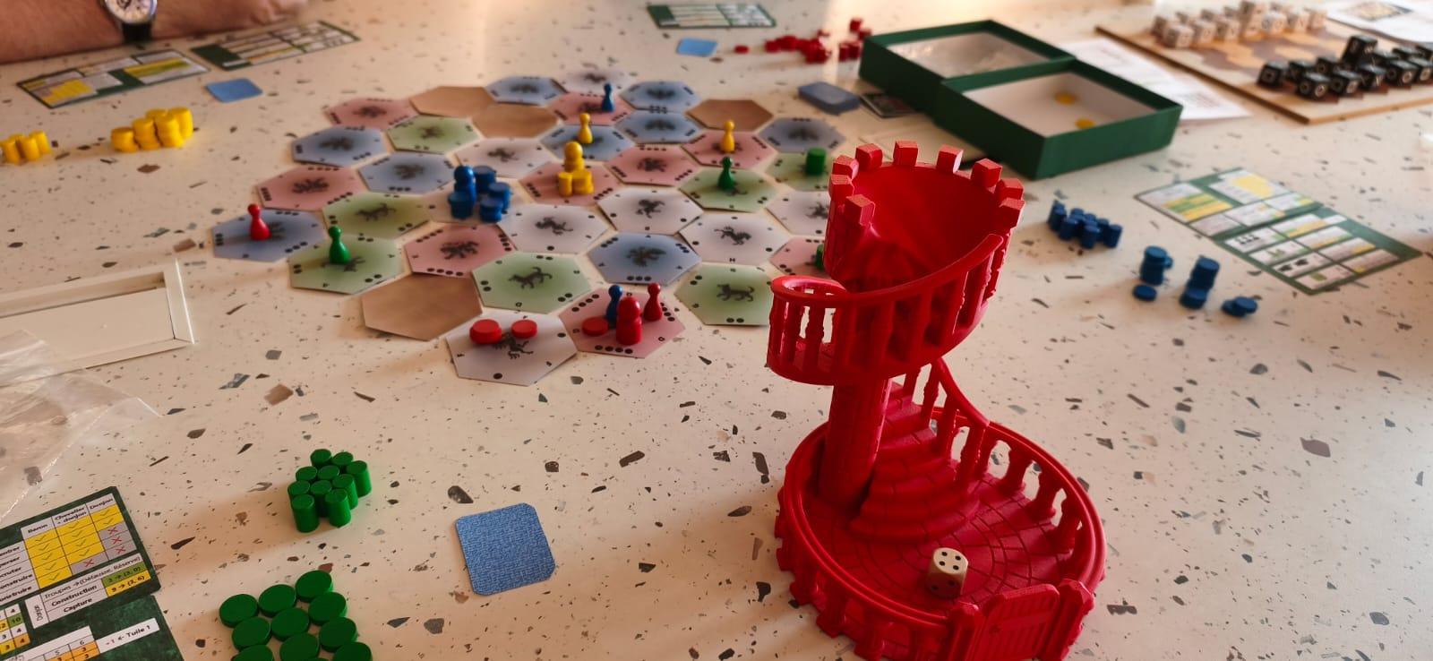

Tactical card

Mountain

Reserve of green

Discard

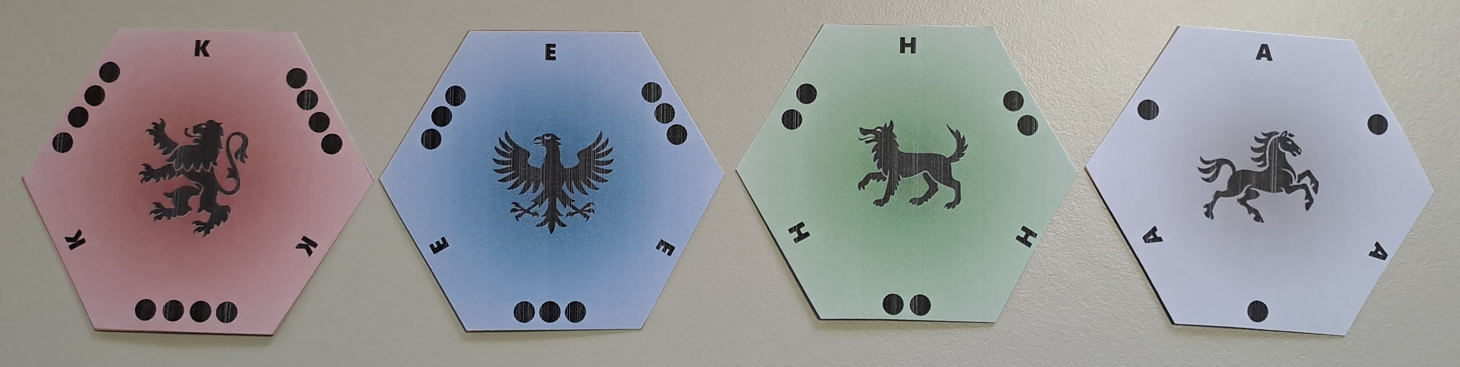

The 4 types of land to conquer

# Components

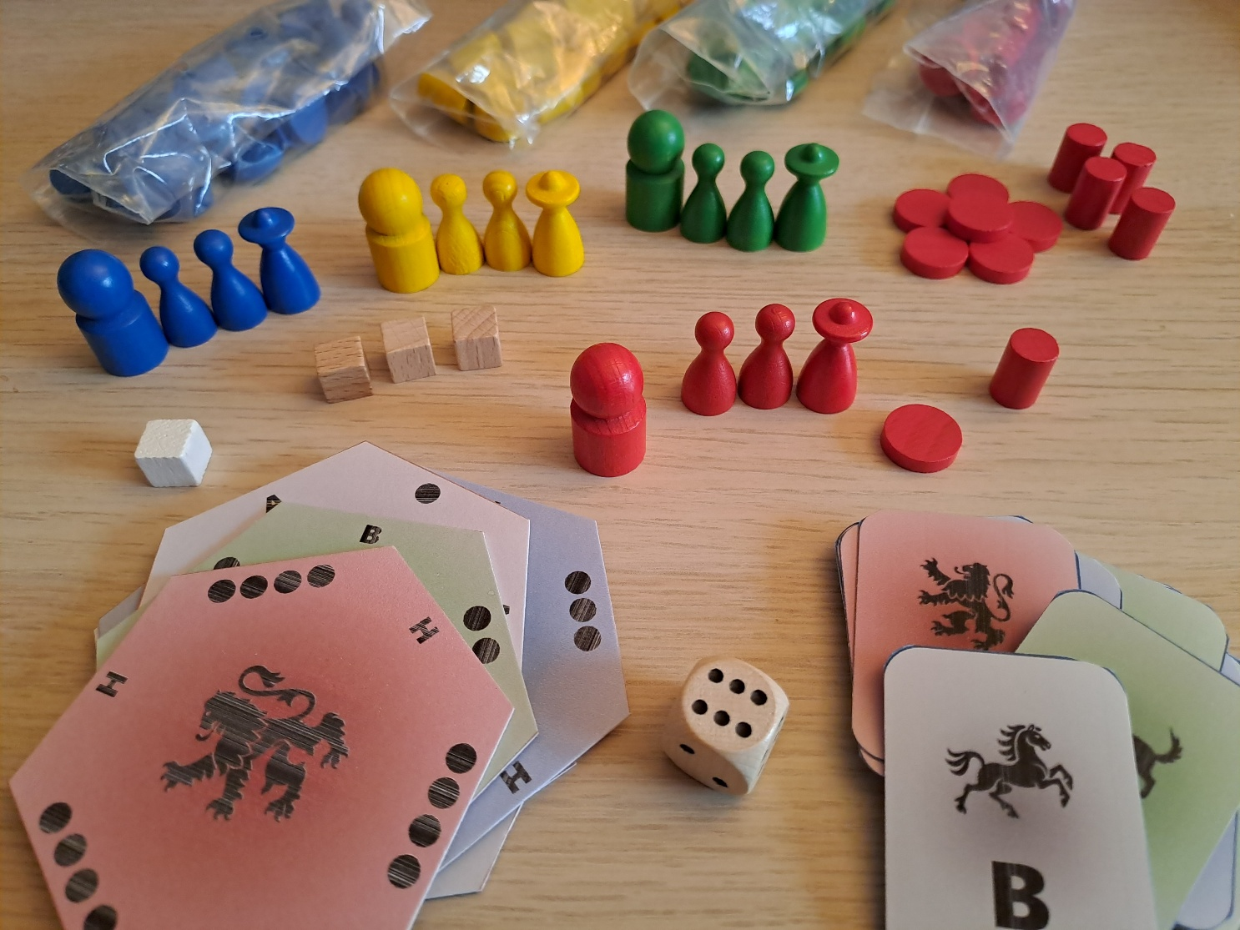

37 tiles

37 tactical cards

1 die

4 sets {1 Baron, 3 Knights, 30 Troops, 10 Donjons }

30 Troops

10 Donjons

1 Baron

3 Knights

1 Free City

3 Merchant Cities

* 37 **hexagonal tiles**, each identifiable by color and a letter. Each tile represents, on the front, a land to be conquered of 1, 2, 3, or 4 points, and on the back in brown, an impassable mountain. The points of the tiles are associated with a color and a heraldic symbol: 4=Red=Lion, 3=Blue=Eagle, 2=Green=Wolf, 1=Gray=Horse.
* 37 **tactical cards**, each identifiable on the front by color and a letter, like tiles.
* A 6-sideddie.
* 1 **Free City** cube and 3 **Merchant City** cubes.
* **Each player** has a large **Baron** pawn, 3 small **Knight** pawns, 30 **Troop** tokens and 10 small **cylindrical** Donjons in their own color.
* In addition to the booklet of the detailed rules of the game, 2 **memo sheets** of the rules for each player.

# Goal

You earn tile points by building Donjons in them, and you lose these points if your Donjons are destroyed or deconstructed. The **game ends** immediately without completing the round table: either as soon as a player wins the **challenge** of having a **minimum number of points** (**19 points** for 2 players; **14 points** for 3 players; **12 points** for 4 players), or as soon as a player has **only 5 Troops left or less** (including the board and reserve). Regardless of the stopping condition, players are ranked according to their **tile points**, to which "**prestige points**" and "**diversity points**" are added. If necessary, players are tied first by their number of Donjons, then by their available troops.

A Donjon built on the "**Free City**" site grants **4 prestige points**.   
A Donjon built on a "**Merchant City**" site grants **2 prestige points**.

"Diversity" points are added to the tile points:

* **2 points** for 2 **different colors** of gained tiles.
* **3 points** for 3 **different colors** of gained tiles.
* **4 points** for 4 **different colors** of gained tiles.

# Set Up

The **tiles** are shuffled, then they are placed on the table, front sides visible, according to the hexagonal scheme below.

|  |  |
| --- | --- |
|  |  |

The **tactical cards** are shuffled, then drawn in order to determine the following tiles (first announce the element concerned, then draw its card):

* The 4 **mountain** tiles, meaning the tiles to be flipped face down.
* The "**Free City**" tile (place its cube).
* The 3 tiles for the 3 "**Merchant Cities**" (place their cubes).
* The starting tile for each **Baron**.
* The starting tile for each **Knight** (**2 Knights** are placed for each player).

Players roll the **die**. Tied players roll again the die. The highest die determines the **first player**. The other players line up, in descending order of their dice, following the first player in clockwise order. In counterclockwise order, **starting** with the **last player**, each **player chooses their color** and places their Troops, Donjons, and their **3rd Knight** in the "**reserve**", meaning in front of them and visible to all.

A "**discard**" space for Troops is agreed upon and shared by all players, for example, the game box.

The 4 **tactical cards** designating the mountains are set aside. All the others are gathered and shuffled again to form a **deck**. Each player receives 1 **tactical card** in reserve, face down. Tactical cards can be consulted at any time, and exclusively, by their owner.

The round table is done **clockwise**.

# Overview – General Principles

Before going into detail, let's explain some general principles of the game (see also §4 Goal):

* **Terrain** constraints: only 1 Donjon per tile, and no adjacent Donjons; 2 Barons cannot occupy the same tile at the end of the player's turn; mountains are impassable, including for the transmission of orders to the Troops.
* Your **Officers**, the **Baron** and the two **Knights**, never die. An Officer moves only one tile by default, more if the bonus granted by the die is favorable and even jumps directly to the tile designated by a tactical card.
* Your **Troops** never act on their own. They must **receive an order** from a **command tile**, i.e. from a tile containing in your color: either a Baron, a Donjon, or a Knight-Donjon pair.
* The rules automatically imply that **a tile** contains only **a unique color of Troops**.
* The same **Troop** must never be **moved** more than **once per turn**.
* The **Troops** always move in a straight line, by dispersing or concentrating, from or to a command tile, by any number of tiles, limited however by a few rules.
* **Troops** follow a **life cycle**: first recruited on order from your reserve, before being dispersed/concentrated, or discarded to build (again on order) a Donjon (3 Troops for 1 Donjon) or discarded because attacked by other Troops.
* **Confrontations**, either Troop versus Troop, or Troops versus **Donjon**, are mainly caused by Troop concentrations and dispersals. In the Troop-Troop confrontation, the attacking Troop returns to the player's reserve, while the attacked Troop is placed in the discard space. A Donjon is destroyed by 3 attacking Troops, which then return to the player's reserve. More powerful than the Donjon attack, the "**Donjon Capture**", which engages 9 attacking Troops, allows you, in a single action, to destroy an enemy Donjon and replace it with your own.
* **Knights** also play a **defensive role**: either by blocking an opponent's command tile, or by limiting the range of the transmission line of concentration or dispersion orders to opposing Troops. On the same tile, Knights of different colors create a "**scrum**" and neutralize each other. Within a tile, only the "**free Knight**"—that is, a Knight outside of a scrum—can effectively defend or form a "Knight-Donjon" type command tile
* **Tactical cards** are played and then discarded: either face down (verso), to force the bonus die; or face up (recto), to immediately move an Officer to the indicated tile. An Officer's action, when rolled on a favorable bonus die, allows the player to draw a new tactical card. Furthermore, on a favorable die roll, discarding 2 Tactical Cards allows a player to recruit an additional Knight.

# Player Turn

Your game turn is organized as follows (see adjacent table):

* First, you roll the **bonus die** and consider the advantages offered (see §9 Bonus die).
* Optionally, you may make a "**Call to the Treasury**" to force the die. The price to pay is to discard a **tactical card face down**.
* Then, you play a first action: either you issue an **order to the Troops** from a command tile, or you perform an **Officer action**.
* Finally, optionally, you play a second action of the same type as the first, including using the same Officer. However, in the same turn, issuing two orders to the Troops requires a "2 Orders" bonus.
* Remember that the advantages of the bonus die are not cumulative. Therefore, if you issue two orders to the Troops, one of which is a recruitment order, then that recruitment must be carried out without a bonus.

It is possible to skip your turn completely.

# Officer Action

The possible actions for an Officer are (see the adjacent table):

* A movement of **1 tile**.
* Or a movement of **several tiles** (not necessarily in a straight line) if the **bonus die** is used (see §9 Bonus die). Starting from **tile 2** with the **bonus die** provides an **extra move of 1 tile**.
* Or a "**lightning** **ride**", which is a move an Officer up to 3 tiles if a **tactical card** is discarded face-down.
* Or a "**long ride**”, which is a jump to the tile designated by a **tactical card**, which is then discarded face-up. If the moved Officer is a Baron, and the designated tile also contains a Baron, then the positions of the two Barons are swapped. No obstacle prevents the "long ride."
* Or a "**collection for the Treasury**", which is the drawing of a **tactical card**, if the **bonus die** allows it (see §9 Bonus die) **OR** in **exchange** for a face-down **discarded tactical card**. This collected tactical card may be played immediately for a "ride" as the second action of the turn.
* **Recruitment of an additional Knight**, if the **bonus die** allows it (see §9 Bonus die) **AND** by discarding **2 tactical cards** face-down. This Knight is positioned: either on the Baron's tile, on an allied Donjon's tile, or on the tile indicated by one of the Tactical Cards, which is then discarded face-up.

# Bonus Die

The table below indicates the opportunities or advantages offered by the bonus die:

* The actions "2 orders to Troops", "collect for the Treasury", or "recruit 1 Knight" are allowed or forbidden depending on the die roll and/or the discarding of Tactical Cards (TC).
* The actions "recruit Troops" or "move an Officer" are always possible, but these actions are amplified depending on the die roll.



# Command Tiles

There are 3 types of command tiles with associated capabilities (see the adjacent table):

* A tile with a **Baron** can issue all orders to the Troops.
* A tile with the **Knight-Donjon** pair can issue all orders to the Troops, except for the construction of a Donjon. This Knight must be "free" (voir §12 Free Knight and Color Scrum).
* A tile with a **Donjon** can only concentrate and disperse Troops.

To give an order to your Troops, first you designate a command tile, then you choose one of the following options (which are detailed later):

* **Recruitment**: recruit new Troops from your reserve **to your command tile**.
* **Construction**: build a Donjon **on your command tile**.
* **Deconstruction**: dismantle your Donjon **on your command tile**.
* **Dispersion**: move your Troops to one or more tiles **from your command tile**.
* **Concentration**: move your Troops from one or more tiles **to your command tile**.

# Knights: Blocking or Limiting Orders to Troops

A command tile occupied by a **free opposing Knight** can no longer issue orders to Troops (see §12 Free Knight and color scrum).

A **Knight-Donjon** command tile can no longer issue orders if its Knight is in a scrum.

A tile with a **free opposing Knight** blocks the transmission of a Troop's **concentration** order when this "blocked" tile is on the path (including start and end) joining the command tile to the commanded Troop. Order transmission must be maintained during concentration.

In a weaker way, Knights **limit** a Troop's **dispersion**: the displaced Troop cannot cross a tile occupied by a **free opposing Knight**. Order transmission must be maintained during dispersion.

# Free Knight and Color Scrum

Within a tile, **Knights** mutually and automatically neutralize each other through "**color scrums**":

* Each scrum (at least 2 Knights) automatically groups the maximum number of distinct and non-repeated colors of Knights on a tile.
* The **free Knight** of a tile is the one who is outside of any scrum. This **free Knight** blocks **any color different** from their own (see §11 Knights: blocking or limiting orders to Troops)

*Two-player example: 1) a Blue Baron cannot command in the presence of a Red Knight; 2) bringing in a Blue Knight deactivates the Red Knight, who does "scrum", and thus unlocks the Blue Baron; 3) bringing in a second Red Knight (out of any scrum) blocks the Blue Baron again, 4) who is again unblocked by a second Blue Knight who does a second "scrum" with the second Red Knight.*

|  |  |  |  |  |  |
| --- | --- | --- | --- | --- | --- |
| 1 | 2 | 3 | 4 |  | ⛔: block **C**: Knight **{ }** : scrum |
| **Baron⛔**  **C1** | **Baron**  **{C1, C1}** | **Baron⛔**  **{C1, C1}**  **C2** | **Baron**  **{C1, C1}**  **{C2, C2}** |  |

*Four-player example : 1) a Blue Baron cannot command in the presence of a Red Knight; 2) Bringing in a Green Knight deactivates the Red Knight, who does "scrum", and thus unlocks the Blue Baron; 3) bringing in a Yellow Knight does not change the situation because the Yellow Knight joins the "scrum"; 4) bringing a second Red Knight (out of the scrum) blocks the Blue Baron again; 5) Bringing in a second Yellow Knight or a second Green Knight or even a Blue Knight constitutes a second scrum that unlocks the Blue Baron again.*

|  |  |  |  |  |  |  |
| --- | --- | --- | --- | --- | --- | --- |
| 1 | 2 | 3 | 4 | 5 |  | ⛔: block **C**: Knight **{ }**: scrum |
| **Baron⛔**  **C1** | **Baron**  **{C1, C1}** | **Baron**  **{C1, C1, C1}** | **Baron ⛔**  **{C1, C1, C1}**  **C2** | **Baron**  **{C1, C1, C1}**  **{C2, C2}** |  |

# Recruit Troops

The presence of an **opposing Donjon**, or one or more **opposing Troops**, **does not block** the recruitment of new troops from your **reserve** onto your command tile (Baron or Knight-Donjon). However, it triggers an immediate **confrontation**, as a mandatory second action, for the recruited Troops: first with any potential opposing Troops (see §19 Troop Confrontation), and then with the potential opposing Donjon if possible (see §20 Donjon Confrontation– destruction). This **special combo** “recruitment + immediate confrontation” **excludes any other additional action** during your turn. Nevertheless, if the opposing Donjon present is not destroyed and no opposing Troops were present, then a second action is possible, as no immediate confrontation took place.

The **number of recruited Troops** is determined by the die roll, and this number is boosted by the presence of an allied Donjon in your command tile (see §9 Bonus die). If you **ignore the die** (by choice or constraint), the **number** of recruited Troops is **minimal**: 1 Troop. When the player's reserve is exhausted, recruitment becomes impossible. However, the die bonus is always automatically satisfied up to the maximum possibilities of the reserve.

A **1-point tile** benefits from an **additional 1-Troop** recruitment when the **bonus** die is **used**.

# Construct a Donjon

If no Donjon is present on the command tile and no allied or opposing Donjon is adjacent, then a Donjon is built by replacing 3 of your Troops present on the command tile with a Donjon. The **3 Troops that built** the Donjon are sent to the **discard space**.

# Deconstruct a Donjon

The deconstructed Donjon returns to your reserve and is converted into 3 Troops taken from the **discard space**, which remain on the command tile. This is the only possible case of retrieving Troops from the discard space.

The presence of one or more **opposing Troops** does not block deconstruction. However, it triggers **an immediate confrontation** between the converted Troops and the opposing Troops (see §19 Troop Confrontation), in a **forced second action**. This **special combo** "deconstruction + immediate confrontation" excludes any other additional action during your turn.

# Disperse Troops

You move as many Troops as you want, **as far as you want from your command tile**, **in a straight line**, provided you respect the rules for crossings and confrontations (see §18, §19, §20 and §21), as if you were moving your Troops one by one.

# Concentrate Troops

You move as many Troops as you want, **in a straight line**, **automatically as close as possible to your command tile**, and provided you respect the rules for crossings and confrontations (see §18, §19, §20 and §21), as if you were moving your Troops one by one. During concentration, be careful to move each Troop only once.

# Troop Crossing

Your moving Troop may cross empty tiles or tiles occupied by your own Troops and Donjons. Your Troop entering a tile occupied by at least one opposing Troop or by an opposing Donjon must stop there, and, if applicable, automatically resolve a confrontation (see §19, §20 and §21).

# Troop Confrontation

Troop confrontation takes priority over Donjon confrontation.

The arrival of your Troop on a tile with the presence of at least one opposing Troop **automatically** causes the annihilation of your Troop and one opposing Troop. Your **attacking Troop** returns to your **reserve**. The **attacked Troop** is sent to the **discard space**.

# Donjon Confrontation– destruction

The arrival of your Troop on a tile with the presence of an opposing Donjon, not defended by at least one opposing Troop, and with the prior presence of 2 of your Troops, causes the annihilation of your 3 Troops and the opposing Donjon; your attacking Troops return to your reserve; the **attacked Donjon** is **not converted back** into opposing Troops (the former building Troops were already placed in the discard space and remain there).

It is the arrival of your 3rd Troop that triggers Donjon's destruction. Your first 2 Troops were merely stopped upon their arrival on the opposing Donjon, and on a later turn, you may move them via a dispersion or a concentration.

# Donjon Confrontation – capture

This confrontation combines, in **a single order** (dispersion or concentration), the destruction of an opposing Donjon and the construction of an allied Donjon, without the intervention of a Baron on the construction tile. For this Donjon capture, **9 attacking Troops** are engaged on the attacked tile:

* The arrival of the 3rd attacking Troop triggers the destruction of the opposing Donjon; the arrival of the 6 subsequent Troops triggers the construction of the allied Donjon.
* **3 attacking Troops** are sent to the **discard space** and **6 attacking Troops** return to the **reserve**.

# Examples of points scores

|  |  |  |  |  |
| --- | --- | --- | --- | --- |
| **Configuration** | **Points** | | | |
| **Tiles** | **Diversity** | **Prestige** | **Total** |
|  | 16 | 0 | 4 | 20 |
|  | 12 | 2 | 4 | 18 |
|  | 15 | 4 | 0 | 19 |
|  | 14 | 3 | 2 | 19 |